1. **Download eclipse SDK**

Visit: <http://download.eclipse.org/eclipse/downloads/>

Choose Latest Release 4.4.2:



Unpack it, and you’ll get the eclipse directory.

1. **Install e4 tools**

Visit: <http://download.eclipse.org/e4/downloads/drops/S-0.17-201501051100/index.html>

This is the latest build of e4 currently. Click here: “online p2 repo link”.



This is the repository address of e4 tools.

Open eclipse.exe, follow “Help -> Install new software”. You will see the Install wizard:

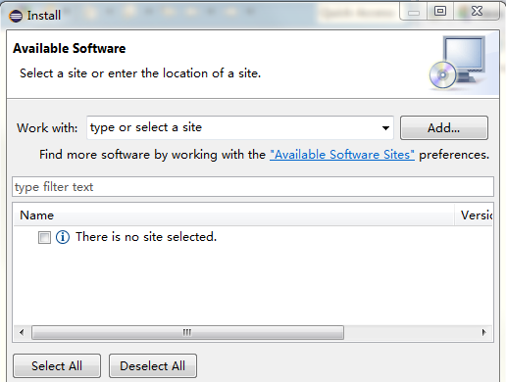

Copy the link address, and paste it into the “Work with” textbox, and press “Add”. Wait a moment, and you will see a list of e4 tools.

Select “Eclipse 4 – Core Tools” and “Eclipse 4 – CSS Spy”, and press “Next”. Then follow the wizard all the way down.

1. **Install other required plugins.**

If your project rely on other plugins, for example CDT, you may now install them on yourself.

1. **Good Luck!**